**Practical 7**

|  |  |  |  |  |  |
| --- | --- | --- | --- | --- | --- |
| |  |  |  |  |  | | --- | --- | --- | --- | --- | | |  |  |  |  | | --- | --- | --- | --- | | |  |  |  | | --- | --- | --- | | |  |  | | --- | --- | | |  | | --- | | **Aim:** Write a VHDL Code to Implement 16 bit adder using behavioral modeling with generic | | | | |   **Code:**  library IEEE;  use IEEE.STD_LOGIC_1164.ALL;  entity adder_16b_bh is  generic(N : integer:=15);  Port ( a : in STD_LOGIC_VECTOR (15 downto 0);  b : in STD_LOGIC_VECTOR (15 downto 0);  c : in STD_LOGIC;  s : out STD_LOGIC_VECTOR (15 downto 0);  co : out STD_LOGIC);  end adder_16b_bh;  architecture Behavioral of adder_16b_bh is  begin  process(a,b,c)  variable i:integer:=0;  variable c1:std_logic_vector( N+1 downto 0);  begin  c1(0):= c;  l1:for i in 0 to N loop    s(i)<=a(i) xor b(i) xor c1(i);  c1(i+1):= (a(i) and b(i)) or (b(i) and c1(i)) or (a(i) and c1(i));  end loop l1;  co<=c1(N+1);  end process;  end Behavioral; |
|  |

**RTL DIAGRAM:** 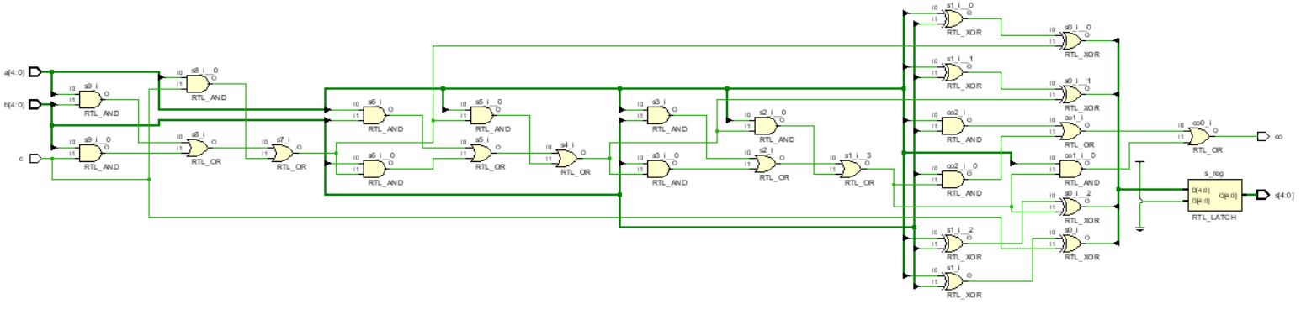

**Test bench Code :**

library IEEE;

use IEEE.STD_LOGIC_1164.ALL;

entity Tb_adder_16b_bh is

generic(N : integer:=15);

-- Port ( );

end Tb_adder_16b_bh;

architecture Behavioral of Tb_adder_16b_bh is

component adder_16b_bh is

Port ( a : in STD_LOGIC_VECTOR (N downto 0);

b : in STD_LOGIC_VECTOR (N downto 0);

c : in STD_LOGIC;

s : out STD_LOGIC_VECTOR (N downto 0);

co : out STD_LOGIC);

end component adder_16b_bh;

signal a1 : STD_LOGIC_VECTOR (N downto 0);

signal b1 : STD_LOGIC_VECTOR (N downto 0);

signal c1 : STD_LOGIC;

signal s1 : STD_LOGIC_VECTOR (N downto 0);

signal c01 : STD_LOGIC;

begin

X1:adder_16b_bh port map(a1,b1,c1,s1,c01);

process

begin

c1<='0';

a1<="0000000000000000";

b1<="0000000000000000";

wait for 10ns;

a1<="1111111111111111";

b1<="0000000000000000";

wait for 10ns;

a1<="1111111111111111";

b1<="1111111111111111";

wait for 10ns;

a1<="1111111111111111";

b1<="1010101010101010";

wait for 10ns;

c1<='1';

a1<="0000000000000000";

b1<="0000000000000000";

wait for 10ns;

a1<="1111111111111111";

b1<="0000000000000000";

wait for 10ns;

a1<="1111111111111111";

b1<="1111111111111111";

wait for 10ns;

a1<="1111111111111111";

b1<="1010101010101010";

wait for 10ns;

end process;

end Behavioral;

**SIMULATION WAVEFORM :**

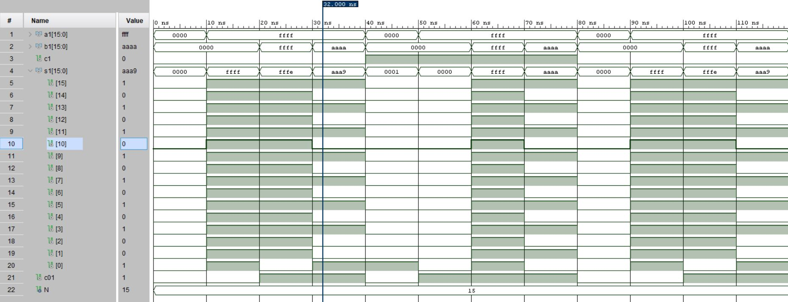

**SYNTHESIS SUMMARY:**

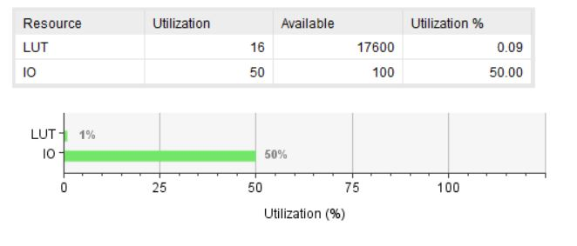

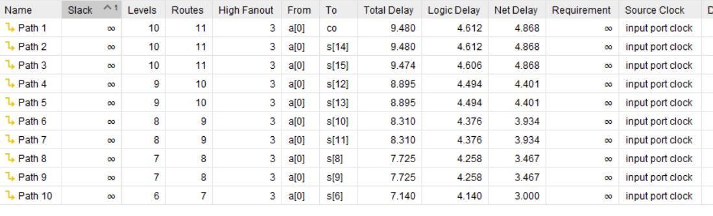

Maximum Combinational Delay: 9.480nSec